Closed Compound Noun

🔹 What is Closed Compound Noun
# Source: AI Source: Provided by: [Data Path: Persons Table -> ID Column: 1, Name_En Column: Motasem Essam] -> From: [Chatgpt (GPT-4-turbo)] on [7/26/2025]
A closed compound noun is a compound noun that is written as one single word, without spaces or hyphens.
✅ It combines two (or more) words into a new word with a specific meaning.

✅ Definition:
# Source: AI Source: Provided by: [Data Path: Persons Table -> ID Column: 1, Name_En Column: Motasem Essam] -> From: [Chatgpt (GPT-4-turbo)] on [7/26/2025]
Closed compound nouns are two or more words joined together to form one solid word that functions as a noun.

📚 Examples of Closed Compound Nouns:
# Source: AI Source: Provided by: [Data Path: Persons Table -> ID Column: 1, Name_En Column: Motasem Essam] -> From: [Chatgpt (GPT-4-turbo)] on [7/26/2025]
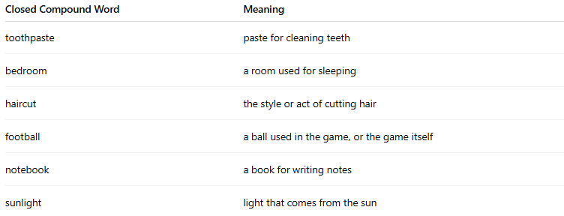
Closed Compound Word | Meaning
toothpaste | paste for cleaning teeth
bedroom | a room used for sleeping
haircut | the style or act of cutting hair
football | a ball used in the game, or the game itself
notebook | a book for writing notes
sunlight | light that comes from the sun

📝 Example Sentences:
# Source: AI Source: Provided by: [Data Path: Persons Table -> ID Column: 1, Name_En Column: Motasem Essam] -> From: [Chatgpt (GPT-4-turbo)] on [7/26/2025]
- I bought a new notebook for school.
- The football match starts at 6 p.m.
- She gave her dog a haircut.
- We painted the bedroom blue.

🔁 Related Comparison:
# Source: AI Source: Provided by: [Data Path: Persons Table -> ID Column: 1, Name_En Column: Motasem Essam] -> From: [Chatgpt (GPT-4-turbo)] on [7/26/2025]
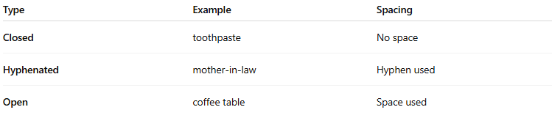
Type | Example | Spacing
Closed | toothpaste | No space
Hyphenated | mother-in-law | Hyphen used
Open | coffee table | Space used

✅ Summary:
# Source: AI Source: Provided by: [Data Path: Persons Table -> ID Column: 1, Name_En Column: Motasem Essam] -> From: [Chatgpt (GPT-4-turbo)] on [7/26/2025]
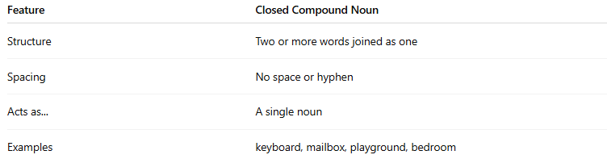
Feature | Closed Compound Noun
Structure | Two or more words joined as one
Spacing | No space or hyphen
Acts as... | A single noun
Examples | keyboard, mailbox, playground, bedroom

